Building Management
- Registration Form
- Registration Check List Form
- Professional Information
- Document Information
Calculated Fee
Registration Form -:
Fill The Registration Form
According To Apply To Land
- Residential
- Commertial
- Public And Private
- Industrial
Proposal Submitted For:-
Five Category of Proposal Submitted For :-
- Approval Of Map
- Change Of Existing Building Use :-
- Revised Proposal of Approved Map
- Reconstruction of Old Line
- Addition Of Existing Building
Details of Plot After Subdivision :-
Whether Change of Land use InvolvedYes or No When Condition Apply to Yes, Two Types of CLU involved
- For Change of land use From The Original Use
- IDP/Development Plan To Other Land Use
Charges Apply According To Given Data
Registration Check List Form :-
All Field Are Filled By As per regulations With Remarks Then Submitted to Next Level
Professional Information :- Fill to Each Field of Professional Information And click to Submitted

Document Information :-
Upload To All PDF File Then Click to Submit
Calculation Fee :-Calculated by According To Given Document Information

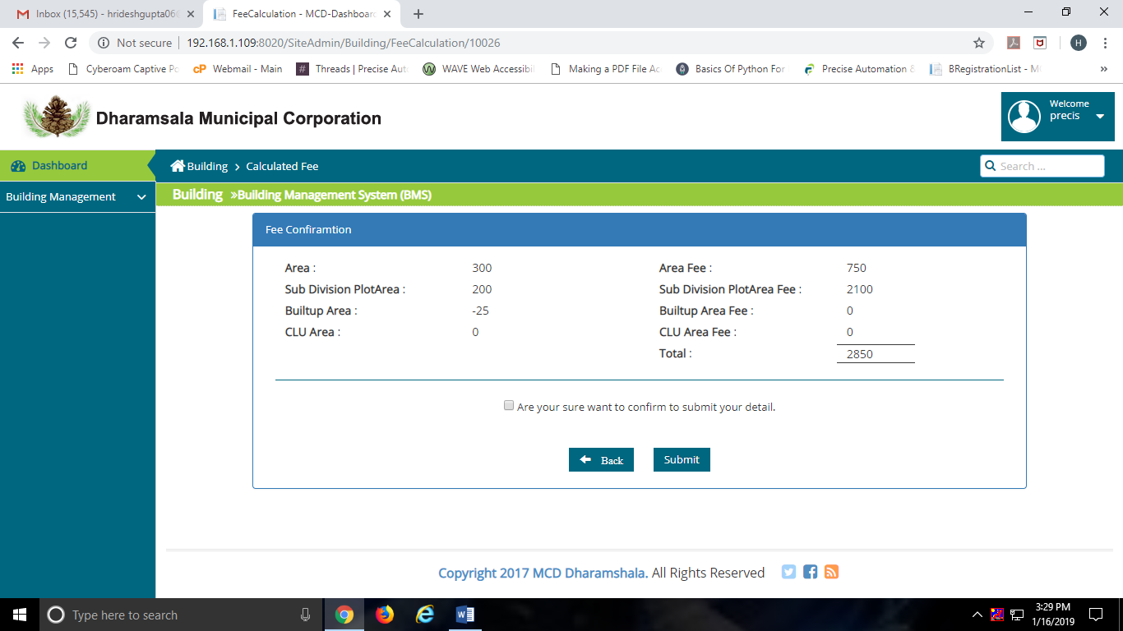
Then Click to Check Box For Confirmation
Now Approved By Officers
draftsman | BAMSDraft@gmail.com
Architect | BAMSArchitect1@gmail.com
Patwari | BAMSPatwari@gmail.com
JE | BAMSJE@gmail.com
Architect2 | BAMSArchitect2@gmail.com
Municipal Engineer | BAMSMEApproval@gmail.com
ExEn | BAMSExEnApproval@gmail.com
Addl Comm | BAMSAddlCommApproval@gmail.com
Comm | BAMSCommApproval@gmail.com

Payment :

